QuizApplication

It is a simple quiz application which asks questions based on difficulty and stores the highscore .

Features : -

* It Does not get reseted when the user changes the orientation.
* It randomly gives the questions based on difficulty.
* The questions are stored on database .
* It has a timer and when its over the button changes from confirm to next.
* If the user tries to go back he gets a toast after that toast gets appeared after a user tries to go back he lands on starting page of application.
* It Shows The Timer, No Of Questions and Difficulty Level.

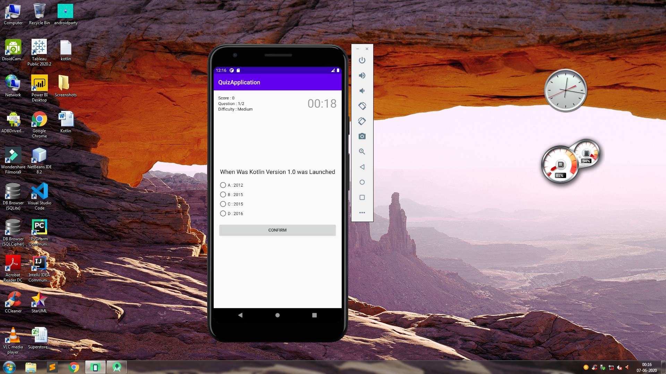

**Concept 1 :**

**Object Oriented Paradigm in Kotlin : -**

I know Java As A Programming Language but very new to android programming so i implemented object oriented programming by creating private functions and classes in this project

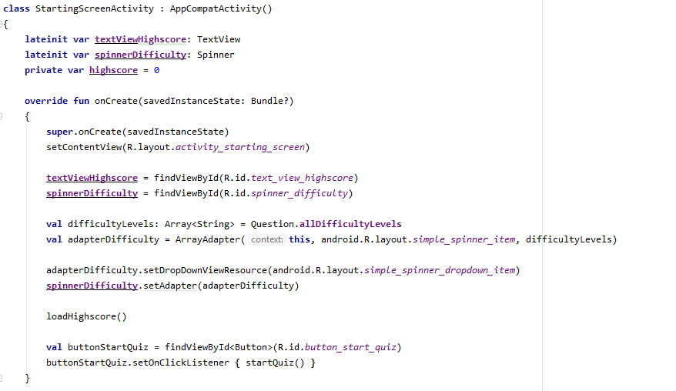

**MVC Architecture Or Design In Kotlin :-**

I also implemented MVC architecture

I created Question.kt Class As The Model

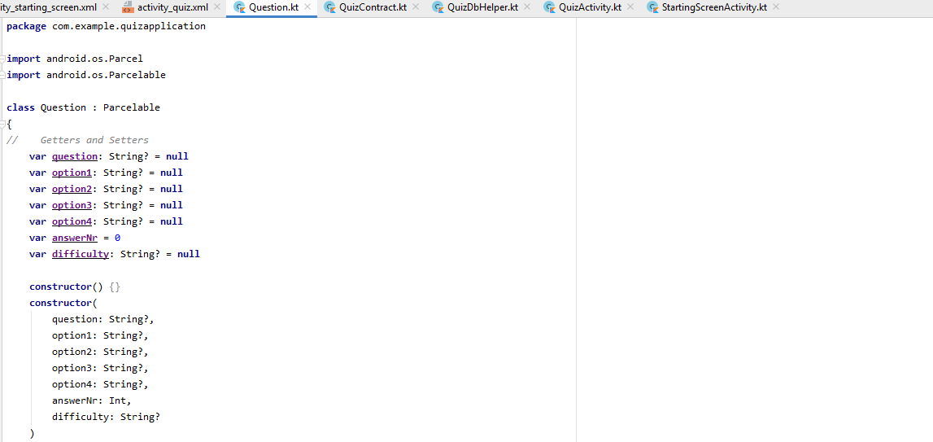

activity_quiz.xml and activity_starting_screen.xml as View

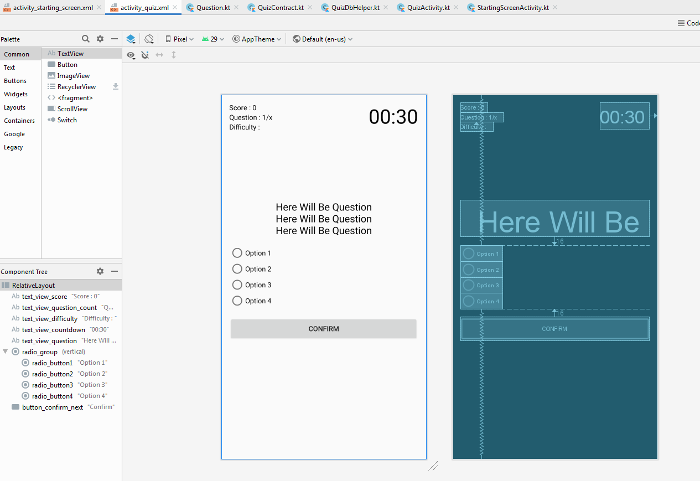

and QuizActivity.kt as Controller

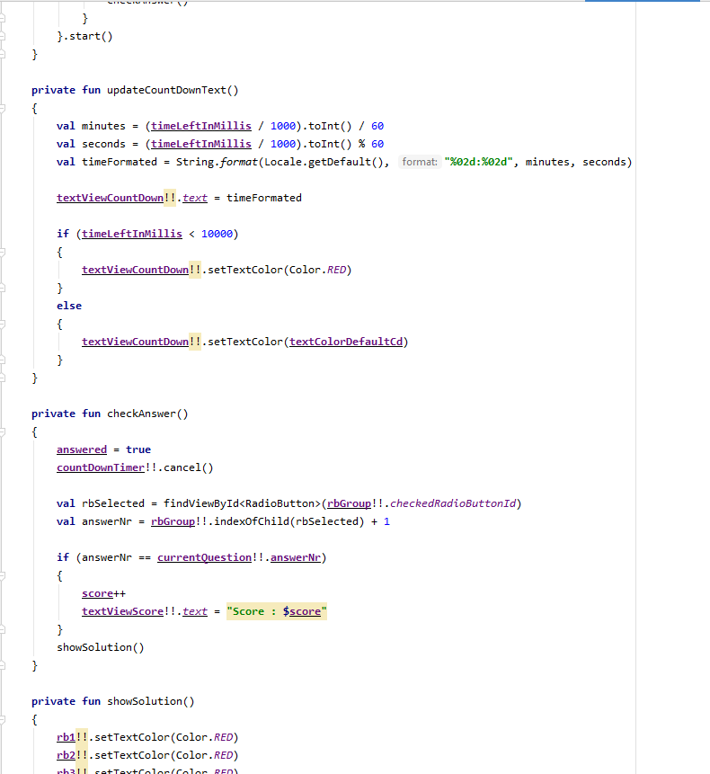

Learned From : -

Kotlin Bootcamp For Programmers

Lession 4 classes and objects

Lession 5 lists extension functions generic classes and functions

**Concept 2 : Layouts**

I implemented Relative Layout in Both Of My xml files

Learned about Different Types Of Layouts and Implemented Relative layout into my application



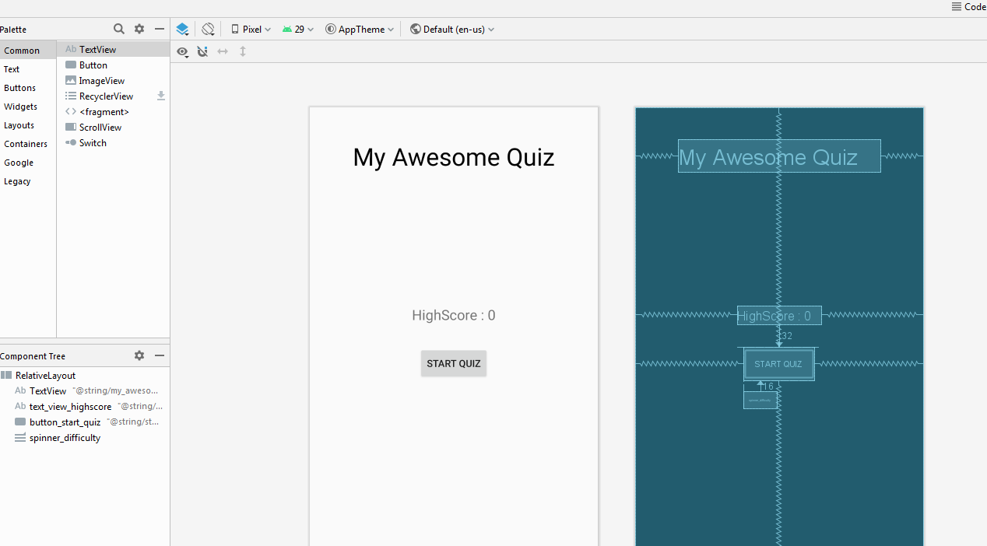

RelativeLayout is a very powerful utility for designing a user interface because it can eliminate complexity of multiple nested Constraint Layout and keeps layout hierarchy flat.

Learned From : -

Android Kotlin Fundamentals

Lesson 2 Layouts

**Concept 3 : SQLite Database**

I implemented SQLite database for fetching data for my quiz app and used a single file which creates database and do operations explicitely in QuizDbHelper.kt .

Learned From

Android Kotlin Fundamentals

Lesson 6 Database

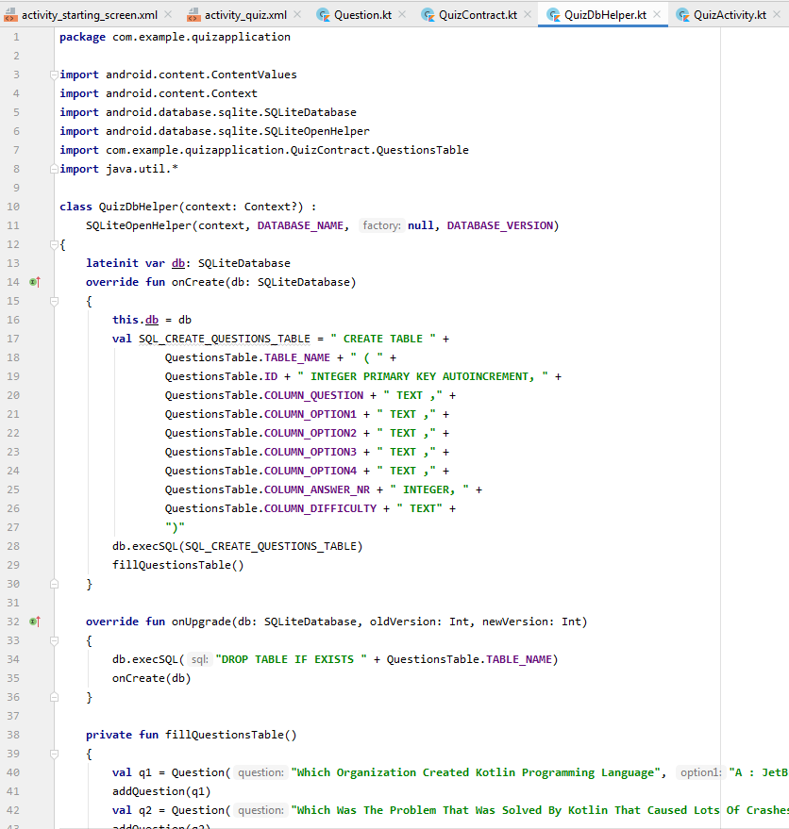

**Concept 4 : companion object**

companion object as it does not require a class to be created

for storing the state of the timer and options and other variables so that when the user changes the layout from horizontal to vertical the state does not get reset

Learned From from Kotlin Documentation

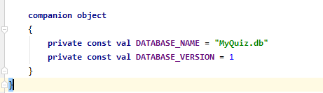

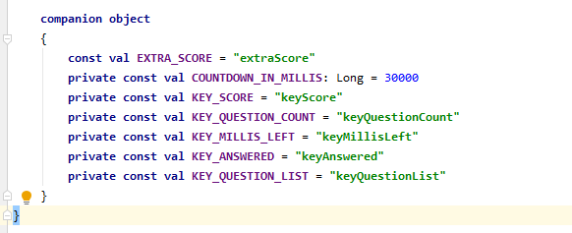

**Concept 5 : Parcelable Class**

[Parcelable](https://developer.android.com/reference/android/os/Parcel.html) is an Android-specific interface, created to be far more efficient than Serializable, and also to fix problems around regular Java serialization.

I implemented parcelable class and its bjects to pass values from one layout to another.

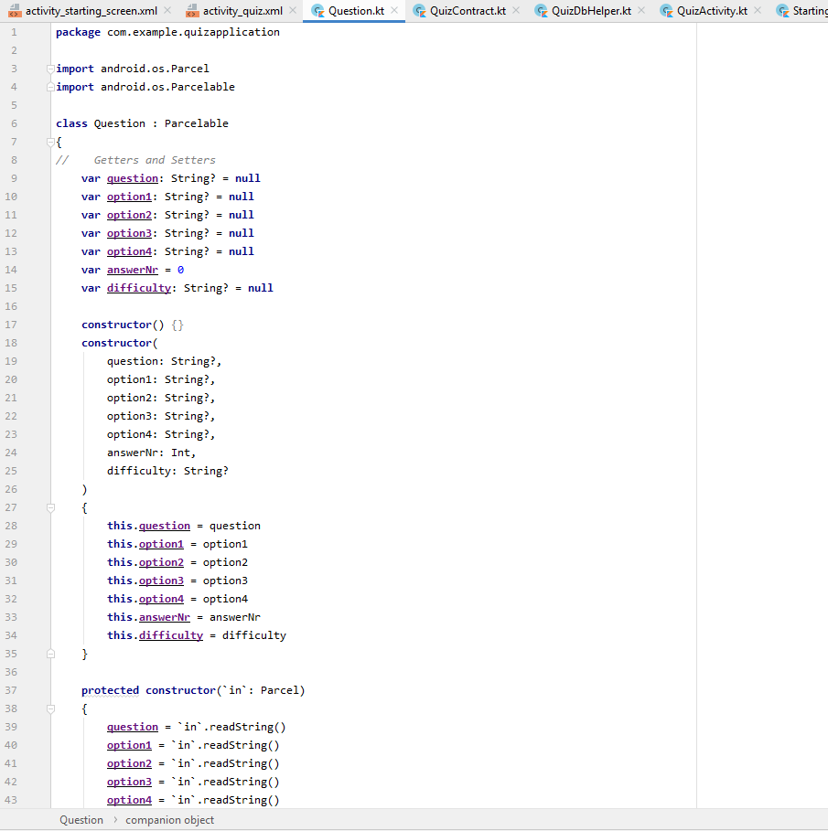

**Concept 6 : Spinner Drop DownList**

Android **Spinner** is a view similar to dropdown list which is used to select one option from the list of options. It provides an easy way to select one item from the list of items and it shows a dropdown list of all values when we click on it.

Default value of the android spinner will be currently selected value and by using **Adapter** we can easily bind the items to spinner object.

I selected it for selecting difficulty leyels in my application.

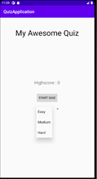 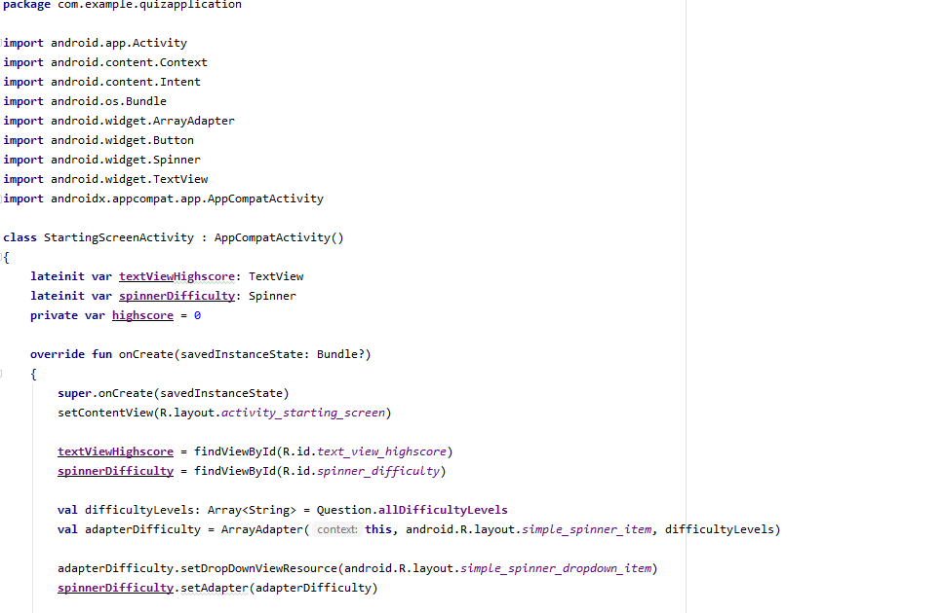

Landing Page

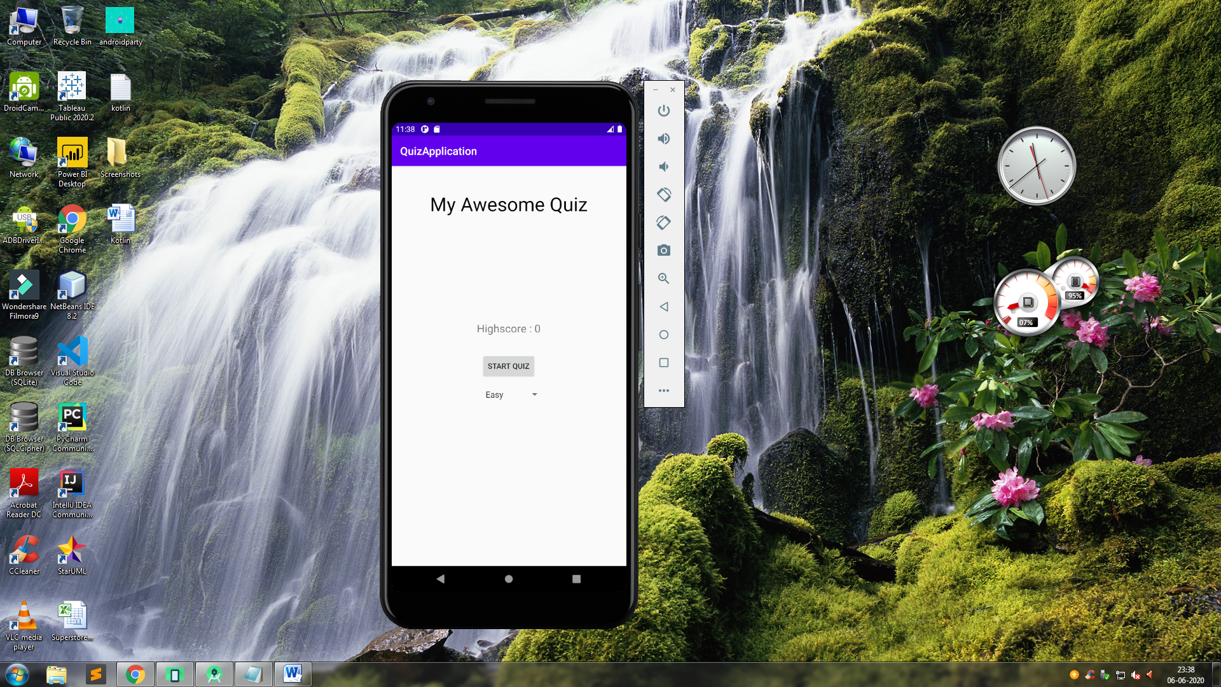

Spinner With Difficulty Options.

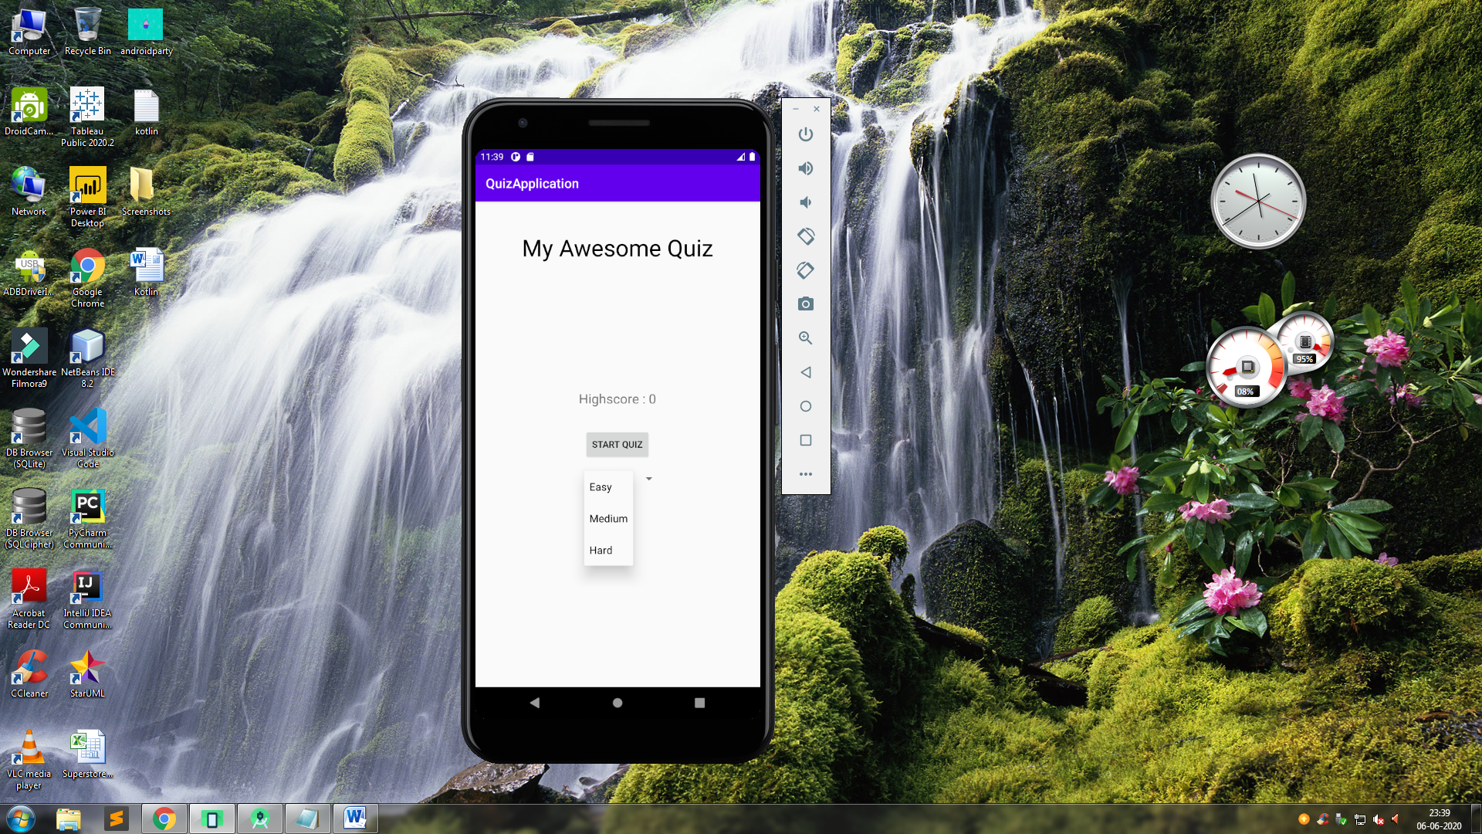

Questions Based On Medium Difficulty



When Not Clicked It Shows Correct Option in Green

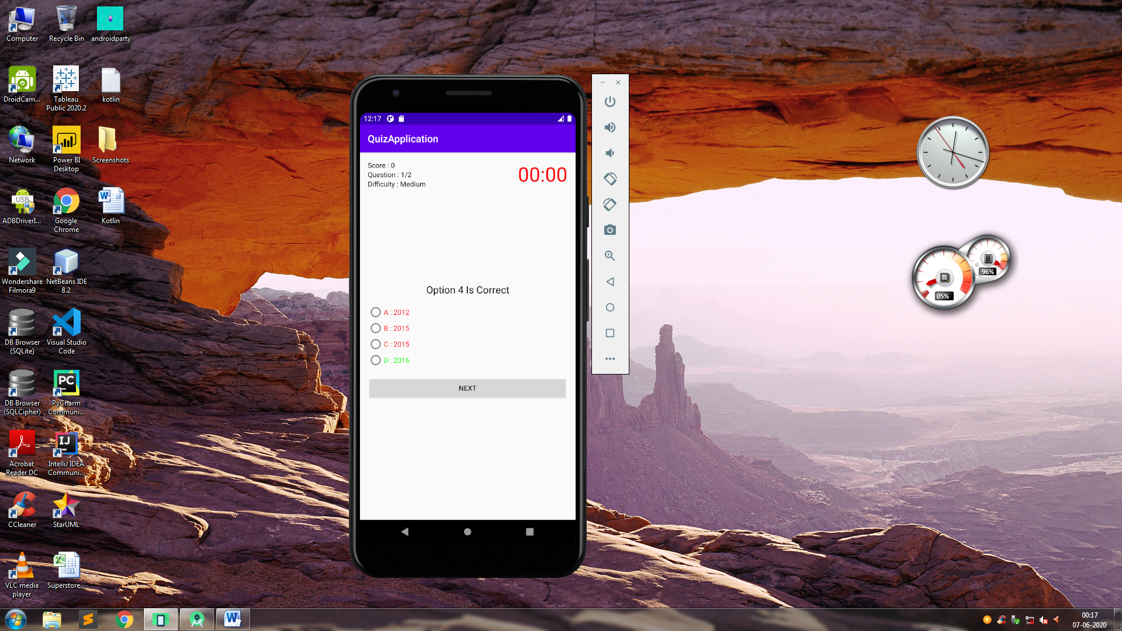

When The User Gives The last Question The Button gets changed from confirm to Finish

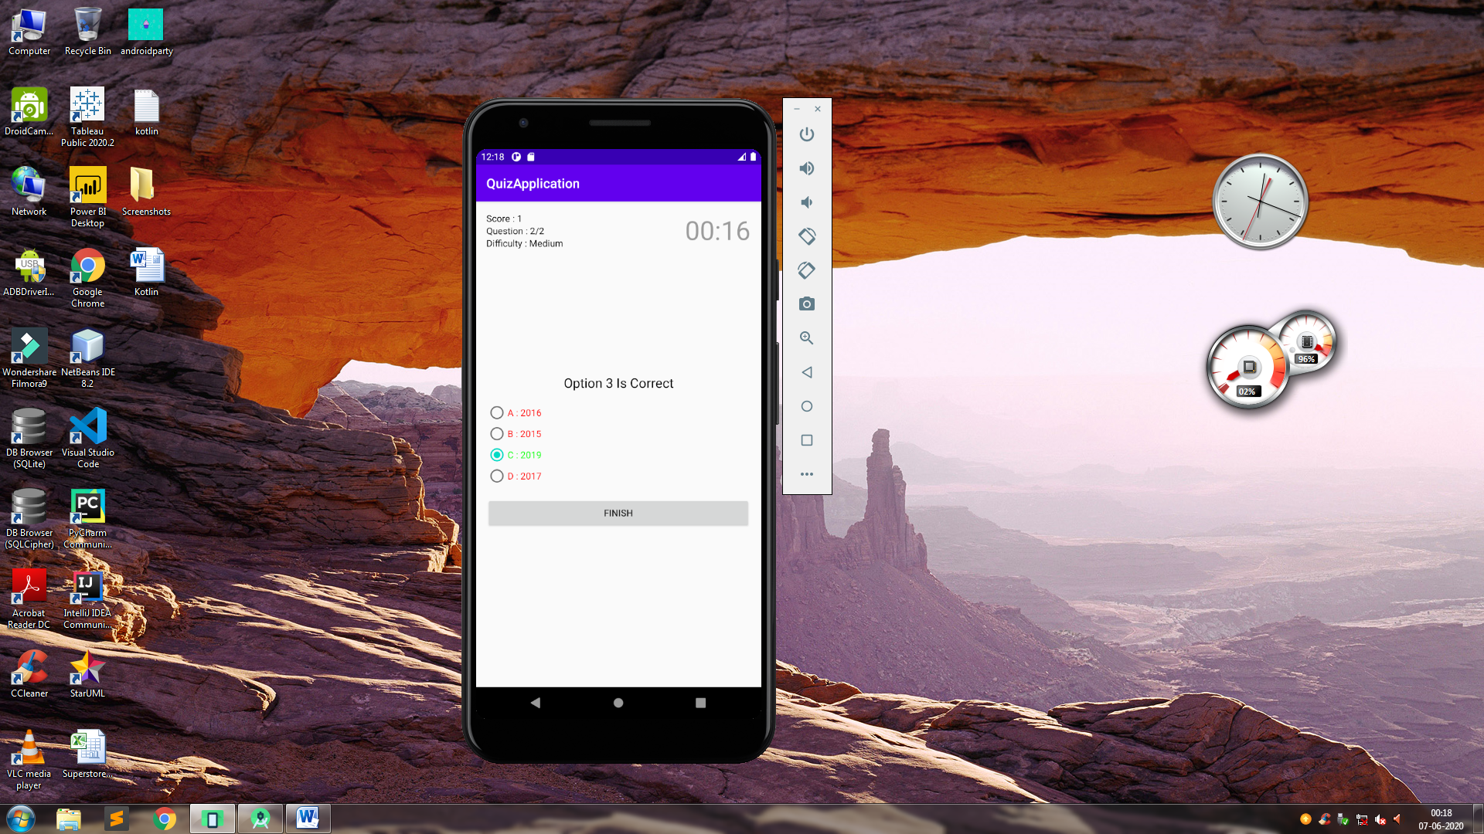

Easy Difficulty Screenshots

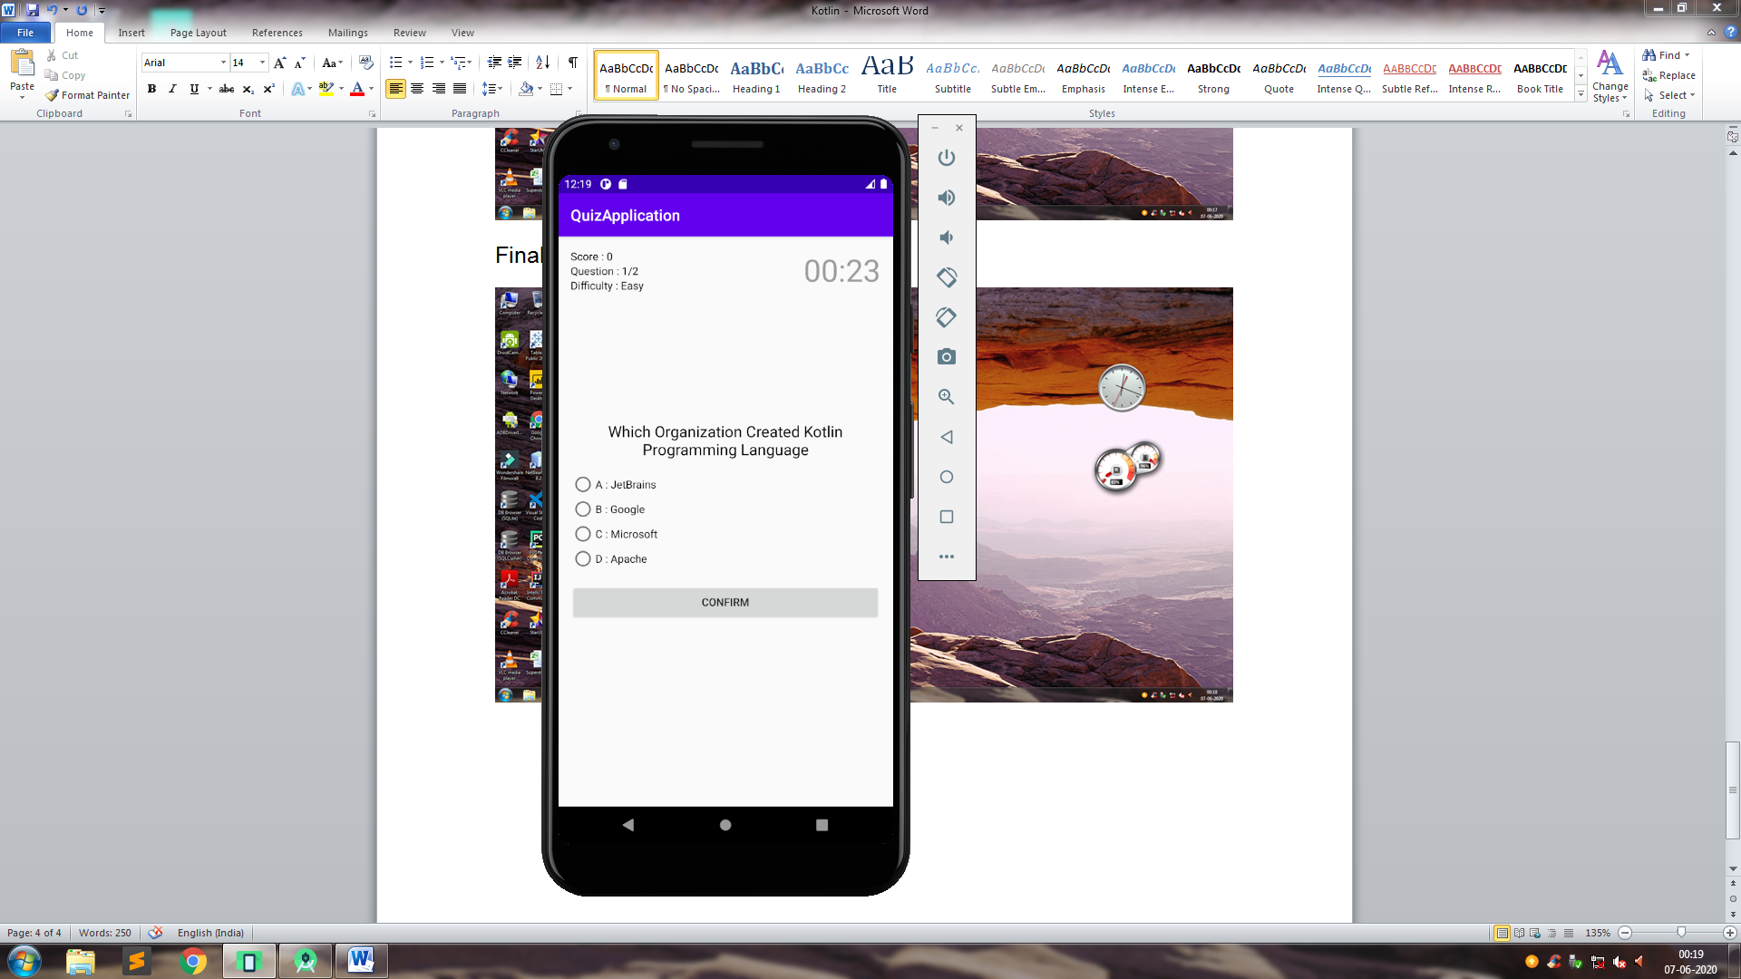

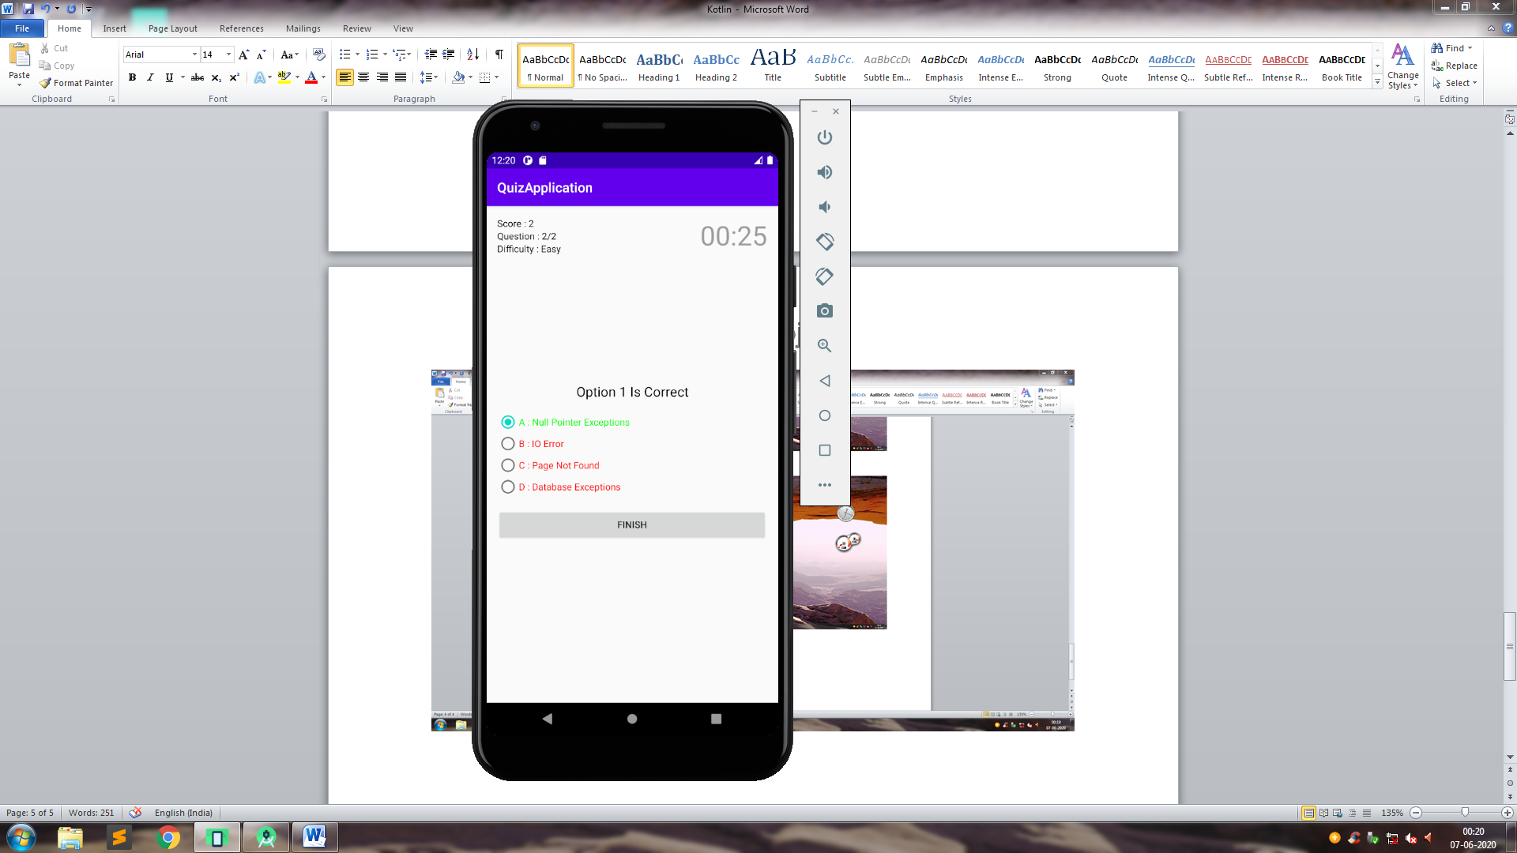

Hard Difficulty Screenshots

